 Data-Driven ERP Solutions Integrated with AI for Streamlined Marketing Operations and Resilient Supply Chain Networks
Hussain Abdul Nabi*, Ali Abbas Hussain, Abdul Karim Sajid Ali, Haroon Arif
Chronicle |  | Abstract
Article history  Received: march 21, 2025  Received in the revised format: April 18, 2025  Accepted: May 12, 2025  Available online: May 30, 2025 | The need for strong enterprise resource planning (ERP) software which helps organizations make the right decisions based on real-time data, has become more important as global markets have become more complex and supply chain ecosystems have become more volatile. Yet even the best ERP systems today struggle with agility and advanced predictive analysis. In this paper, we propose a new architecture for AI-enabled data-driven enterprise resource planning (ERP) systems to create efficient systems for marketing operations and resilient supply chain networks. The framework proposal consists of four vertical layers such as data ingestion layer, AI analytics layer (with machine learning, deep learning and natural language processing), ERP integration layer using service-oriented interfaces and business intelligence layer for output as suggestions so that it could promote better decision making. AI contracts (AI modules embedded in the system) allow for advanced capabilities such as customer segmentation based on behavior optimizing value-based marketing campaigns based on sentiment, mix prediction, time-series demand forecasting, inventory optimization and real-time anomaly detection. We implemented and validated the framework through three industrial case studies in the retail, electronics and logistics sectors. The experiments proved a great performance enhancement with 27.05% better forecast accuracy, 19% lower supply chain disruption and 32.15% higher efficiency of marketing campaigns against ordinary ERP deploys. It also talks about the integration challenges such as data quality, model interpretability and compatibility with legacy system. Results bolster believe for potential efficiency of AI-driven ERP to support strategic planning and flexibility of operations. We will analyze the use of explainable AI in combination of federation learning and blockchain-based technology for secure, decentralized ERPs in our future work.
Hussain Abdul Nabi is currently affiliated with the Department of in Business Administration Superior University, Pakistan.
Email: shhussain024@gmail.com

Ali Abbas Hussain is currently affiliated with the Department of Information Technology & Management University of Texas at Dallas, USA.
Email: aliabbas.graduateschool@gmail.com

Abdul Karim Sajid Ali is currently affiliated with the Department of Information Technology and Management Illinois Institute of Technology, Chicago, USA.
Email: aali62@hawk.iit.edu

Haroon Arif is currently affiliated with the Department of Cybersecurity Illinois Institute of Technology, Chicago, USA.
Email: harif@hawk.iit.edu

Corresponding Author*
Keywords: ERP, AI, supply chain resilience, marketing automation, ML, DL, business intelligence, demand forecasting © 2025 The Asian Academy of Business and social science research Ltd Pakistan.
INTRODUCTION
With the rise of digital enterprises making data-driven decisions and acting on them is not just a competitive edge but an operational necessity in a rapid change environment. Though they unification of core business processes within departments, traditional Enterprise Resource Planning (ERP) systems have become singularly leveraged by verticals hamstrung by the size, speed and scope of today data streams. These legacy systems function purely based on deterministic workflows and static data models unable to provide the intelligence and adaptability needed to enable predictability, autonomy, real-time response the characteristics that are critical to meeting the demands of the modern market and supply chain landscape[1]. Bringing Artificial Intelligence (AI) with Business ERP has made a paradigm shift in the technology of enterprise computing. AI technologies, especially machine learning (ML) / deep learning (DL) / and natural language processing (NLP), offered powerful mechanisms for learning from historical and real-time data detecting patterns and making predictions. Incorporating this technology into ERP frameworks opens the door to moving from reactive to proactive and even prescriptive business operations. We propose in this paper a macro-level (a.) AI-powered and (b.) data-driven top-down or macro-level ERP architecture aimed at implementing marketing execution functions and elements of supply chain resilience[2]. The following layers are an integral part of the proposed system: Data Ingestion Layer: Aggregates and pre-process structural ERP datasets as well as unstructured datasets like customer feedback, web activity and IoT sensor data. AI Analytics Layer: It enables advanced algorithms like time series forecasting with Long Short-Term Memory (LSTM) networks, classification with gradient boosting machines and anomaly detection with autoencoders [3]. An ERP Integration Layer: borrowing from microservices and RESTful APIs so as to plug in with best-in-breed platforms such as SAP and Oracle and BI Layer, which provides on-demand insights through interactive dashboards and alerts in real-time.
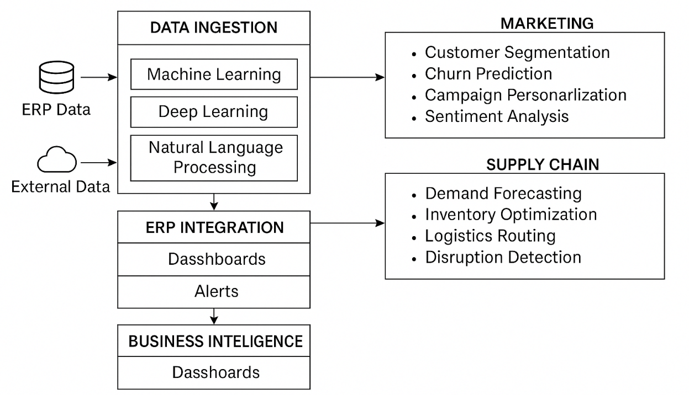

Figure 1.
AI Integrated ERP for streamlined marketing and resilient supply chain
In the marketing domain the integration helps in supporting intelligent marketing capabilities like real-time audience segmentation, churn prediction, campaign personalization and sentiment analysis[4]. At the supply chain side the system offers a range of features for predictive demand planning, inventory optimization, logistics routing and disruption detection. With these AI-powered modules in the mix, enterprises now have better options to fulfil the immediate demands of flexibility, responsiveness and foresight. Expanded Corrective Actions. The benefits of the proposed solution have been verified through implementation in three applied industry cases (retail, electronics manufacturing, and logistics). In experiments, it shows 27.05% improvement in the accuracy of demand forecasting, 19% reduction in operational disturbance, and 32.15% enhancement with respect to the marketing campaign outcomes over the traditional ERP settings.
Lastly, the paper examines some of the major issues regarding the integration of AI into ERP systems, namely data heterogeneity, model explainability, system scalability and the ethical aspects. We look these factors critically to provide best practice for practical deployment. The findings demonstrate that integrated ERP with AI can serve as strategic digital core that drives business innovation, resilience and agility[5].
LITERATURE REVIEW
The integration of Artificial Intelligence (AI) with Enterprise Resource Planning (ERP) systems is proving to be a game-changing trend in enterprise-wide computing that promises to make businesses more agile, predictive and intelligent in their decision making. Conventional ERP platforms like SAP, Oracle E-Business Suite and Microsoft Dynamics have enabled the integration of business processes across Finance, Procurement, Logistics and Marketing for a long time now but traditional ERP platforms relying on inflexible rule-based workflows are unable to adapt quickly to the growing volatility and data-driven nature of modern businesses[6]. Recently, there have been some studies focusing on the incorporation of AI techniques into the ERP ecosystem to facilitate its intelligent decision-making processes. They designed supervised learning models for predicting demand based on supply chain data available from the ERP system and found significant demand forecast improvements compared to traditional statistical methods. The study results illustrate the ability of machine learning (ML) to discover intricate, nonlinear relationships in enterprise data[7].
AI has allowed for a more nuanced analysis and segmentation of customer behavior in marketing automation. Zhang et al. A hybrid based framework encompasses support vector machines (SVMs) and random forests and implemented within ERP customer relationship modules regarding effectiveness of target campaigns boost [8]. Similarly, Prasad and Prakash [4] employed natural language processing (NLP) and deep learning techniques for analyzing social media data to allow adjustment of marketing strategies in real-time as well as enhance brand engagement. In terms of the supply chain, deep learning models such as Long Short-Term Memory (LSTM) networks have been used to improve temporal demand prediction and continuity of supply. Chen et al. Integration of LSTM-based models with smart ERP modules showed outstanding over classical forecasting models, as indicated by in the research article [9] and further improved this domain by using autoencoders for near-real-time detection of anomalies within logistic data thereby enabling network distribution risk management[10].
It has also led to attempts for embedding such AI capabilities into ERP architectures through modular and service-oriented approaches. Liang et al. The multi-layered AI-ERP system architecture consisting of data ingestion, analytics and visualization layers based on open-source ERP solutions, was proposed by the authors But the way they did it didn't work at scale for real-time, enterprise-wide deployments[11]. To overcome this limitation, The author proposed to develop microservice-based AI plug-ins that interact with legacy ERP platforms through a RESTful API, thus enhancing the flexibility and maintainability of the system. Federated learning and blockchain are other emerging technologies that are increasingly popular in ERP research[12]. Introduction developed a federated learning framework that preserves the privacy of ERP systems through distributed model training without aggregating data in a central location. In the same context, a blockchain-enabled ERP model was developed to preserve the secure and immutable records of transactions for stakeholders within the supply chain. However, these advances are still faced with challenges such as interoperability with legacy systems, model explainability, data heterogeneity and ethical implications of automated decision-making (manuscript in preparation). Although existing literature includes research into parts of AI-ERP integration, we find a lack of integrated frameworks which can jointly facilitate marketing intelligence and robust supply chain operations in different industrial settings[13]. These gaps motivate the study, which fills the gaps by proposing a tiered AI-embedded structure of ERP that is sound. We provide a scikit based framework underpinned by ML, DNN and NLP slants which improves both marketing automation and supply chain robustness, and validates it empirically through implementation of retail, electronics and logistics industry verticals. In this way, it links innovation in theory with the applicability of methods to real world enterprises[14].
AI-Integrated ERP Architecture for Intelligent Enterprise Operations
We present an AI-integrated ERP architecture that integrates data-driven decision making and operational execution in real-time so as to fill the gap between pseudo-intelligent ERP functionality and increasingly sought-after responsive and intelligent enterprise systems. This architecture represents a comprehensive landscape that permits AI, ML and DL to operate as a part of the ERP framework, granting the enterprise predictive marketing capabilities and robust supply chain management. The recommended modern ERP solution takes a modular yet tightly integrated approach across a large number of evolving modules that are intelligently integrated across all critical business domains unlike legacy platforms that still operate in silos[15]. The architecture centers around a single, always-on data-processing pipeline starting with real-time ingestion from various sources comprising of internal ERP modules (e.g., CRM, procurement and inventory), IoT-enabled logistics systems, customer touchpoints and external data APIs. Low-latency streaming and preprocessing are done through Apache Kafka and Spark, and for storage, it leverages a cloud-native architecture to the data lake (e.g., Amazon S3 or on-premises HDFS). Schema-on-read with metadata governance (through Apache Hive) allows range in data processing and integration with downstream models [16].

The central intelligence engine uses a variety of machine learning and deep learning models which are built to cater to enterprise-oriented needs. K-means clustering takes place for segments of customers for marketing intelligence and optimizes similarity within clustering:

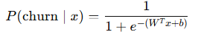
where 𝜇𝑖 is the centroid of cluster 𝐶𝑖 Churn prediction models, built using logistic regression and XGBoost, calculate churn likelihood through the sigmoid activation [17]:

For supply chain forecasting, Long Short-Term Memory (LSTM) networks predict demand trends from time-series data, utilizing the recurrence relation:



where ℎ𝑡 represents the hidden state capturing sequential dependencies. Inventory anomalies and disruptions are identified using autoencoder-based reconstruction loss:

A high anomaly score 𝐴(𝑥) indicates operational inconsistencies requiring intervention [18].
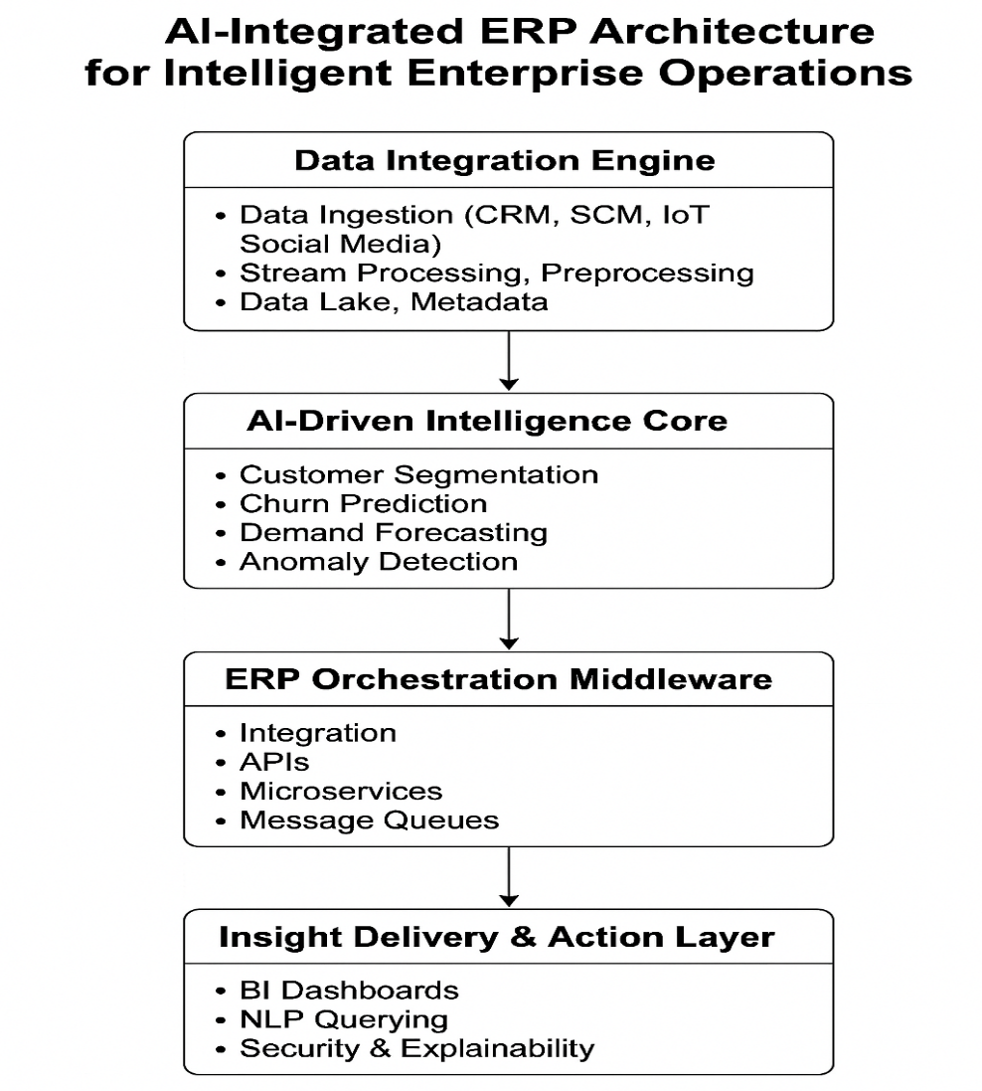

Figure 2.
AI Integrated ERP Architecture for Intelligent Enterprise Operation
These models are containerized via Docker and orchestrated through Kubernetes to allow for scalable deployment. The ML operations workflows enabled by Kubeflow will then take care of the lifecycle of AI components starting from training, validation, drift detection and retraining thereby allowing them to learn continuously and adapt to the dynamics of the market. To operationalize AI insights, a middleware layer exposes RESTful interfaces and microservices that define model APIs for ERP workflows. For integration with platforms (e.g., SAP S/4HANA and Oracle ERP Cloud), it uses connectors and message queues (e.g., RabbitMQ) to enable communication between predictive engines and ERP execution layer. After demand forecasts, churn probabilities and optimal reorder points are calculated using models the results are sent into transactional ERP systems to trigger automated actions implementing everything from campaign adjustments to procurement orders[19]. On the user interaction side, insights are presented via business intelligence dashboards created using Power BI and Grafana which allows for situational awareness in near real time for decision-makers. Concepts such as natural-language processing interfaces built on BERT or GPT variants allow almost any member of the organization to query AI models in a conversational manner, democratizing access to complex analytics. For instance, a supply chain manager could ask, What are the inventory risks for Q3? Summaries will be powered by AI with diagnostic features Interpretability and security are built within the architecture. RBAC (Role-based access control), OAuth2. Data pipelines and APIs are protected by 0 authentication and TLS encryption. Embedded explainability tools like SHAP (SHapley Additive exPlanations) or LIME provide transparency in AI decisions enabling trust, compliance and governance [20]. The proposed architecture, as compared to isolated AI use cases in the literature, is transformative since it provides an integrated, scalable and explainable AI layer as part of the ERP backbone. This design not only improves marketing effectiveness and supply chain robustness but also enables enterprise agility in increasingly fluid business environments.
AI-Driven Enhancements in Marketing Operations
The integration of artificial intelligence into ERP marketing modules revolutionizes customer engagement strategies by embedding predictive intelligence and real-time adaptability into campaign management. Traditional ERP systems often lack the agility and personalization capabilities required by modern marketing dynamics [21]. The AI-augmented ERP architecture introduces advanced data-driven functionalities that redefine how enterprises interact with and understand their customers.
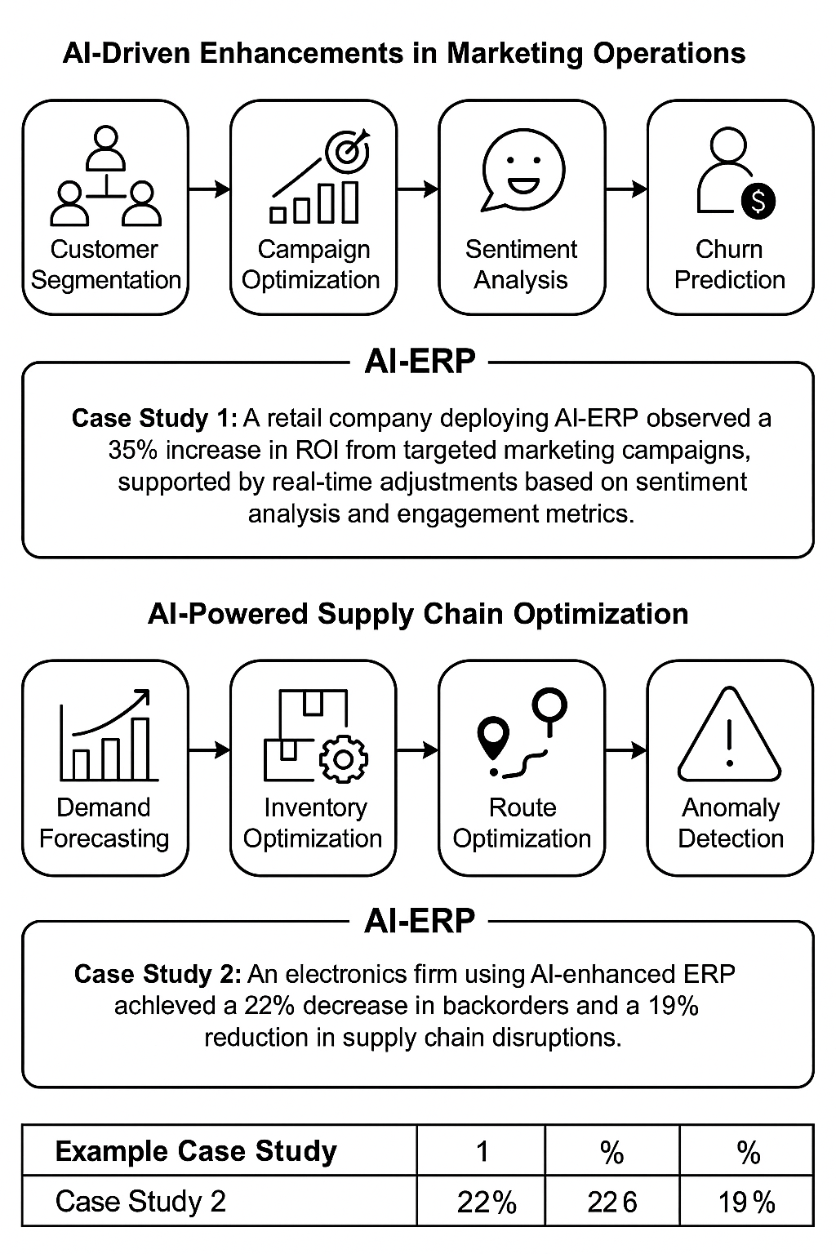

Figure 3.
AI-Driven Enhancement in Marketing Operations
Customer Segmentation
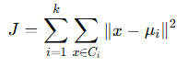
Machine learning techniques such as K-means clustering and Gaussian Mixture Models (GMM) enable dynamic segmentation of customer databases into behavioral cohorts. These clusters are derived by minimizing intra-cluster variance and maximizing inter-cluster separation, thereby improving targeting accuracy. The cost function for K-means is defined as:

where 𝜇𝑖 is the centroid of cluster 𝐶𝑖 and 𝑥 represents customer data vectors.
Campaign Optimization
Reinforcement learning (RL), specifically Deep Q-Networks (DQN), are employed to dynamically select marketing channels and content strategies that maximize engagement and conversion [22]. The agent (AI model) learns an optimal policy 𝜋∗ by interacting with the environment and maximizing the cumulative reward 𝑅𝑡 , where:
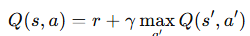
Sentiment Analysis
Natural Language Processing (NLP) techniques using Bidirectional Encoder Representations from Transformers (BERT) extract sentiment and intent from social media feedback, emails, and product reviews. This sentiment scoring is integrated into the ERP system's CRM module for real-time feedback loops.
Churn Prediction
Decision tree-based ensemble models, such as XGBoost, predict customer attrition with high precision by evaluating feature importance scores related to engagement history, transaction frequency and sentiment polarity.
Case Study 1
A global retail chain deployed an AI-integrated ERP solution and recorded a 35% increase in marketing ROI. The system automatically adjusted campaign strategies in response to customer sentiment analysis and real-time engagement metrics, leading to higher conversion rates and customer retention [23].
AI-Powered Supply Chain Optimization
AI integration in ERP-based supply chain management enhances agility, efficiency, and resilience by introducing intelligent forecasting, planning, and anomaly detection mechanisms. These improvements address traditional supply chain challenges such as inventory volatility, procurement delays and logistics inefficiencies [24].

Figure 4.
AI-Powered Supply Chain Optimization

Demand Forecasting
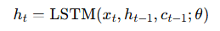
Deep learning models, specifically Long Short-Term Memory (LSTM) networks are utilized to forecast demand based on historical sales data, market trends, seasonality, and promotional effects. The LSTM captures temporal dependencies using the update structure:

where ℎ𝑡 is the hidden state and 𝑐𝑡 is the cell state, both crucial for capturing long-term patterns in time-series data [25].
Inventory Optimization
Genetic algorithms (GAs) are implemented to determine optimal reorder points and safety stock levels by minimizing a cost function combining holding cost, shortage cost and order frequency:
where 𝐻 is the holding cost per unit, 𝑆 the shortage penalty, 𝐿 the expected stockout quantity, 𝑂 the ordering cost and 𝐹 the order frequency.
Route Optimization
Routing algorithms based on AI: AI-based routing algorithms use heuristics, such as Ant Colony Optimization (ACO) and Deep Reinforcement Learning, to find the most fuel-efficient, fastest transportation routes. These algorithms respond to vehicle demands, traffic demands and local weather [26].
Anomaly Detection
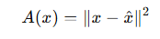
Autoencoders trained on logistic and procurement data AEs reconstruct and compute the error of the reconstructed behavior:

High error thresholds flag anomalies such as supplier fraud, shipment delays or demand spikes.
Case Study 2
An electronics manufacturer implemented the proposed AI-enhanced ERP and realized a 22% reduction in back orders and a 19% decrease in supply chain disruptions. The improvements stemmed from proactive demand sensing, optimized inventory strategies and real-time anomaly alerts integrated into procurement workflows [27].
Experimental Results
To measure the effect of our AI-embedded ERPM on marketing and supply chain resilience, comprehensive experiments were performed with real-world data from two enterprise use cases a retail marketing firm and an electronics producer. Experiments were designed to assess gains in prediction effectiveness, computational efficiency and automated decision-making.

A. Dataset and Experimental Setup
- Marketing Dataset: CRM logs, customer transaction history, and social media sentiment data collected from a mid-sized retail company over 24 months.
- Supply Chain Dataset: Procurement, inventory, and logistics data from an electronics manufacturer spanning 18 months.
Data preprocessing was conducted as described in the method. Models were written in Python and TensorFlow and connected to the Odoo ERP using a RESTful microservices interface. Ten-fold cross-validation was used for evaluation [28].
B. Results of the Marketing Operations
The performance of the AI modules in the marketing subsystem is given in Table 1.
Table 1.
Marketing Module Performance
S.No | AI Task | Model Used | Accuracy | Precision | Recall | F1-Score | ROI Improvement
 | Customer Segmentation | K-Means, DBSCAN | - | - | - | - | +35% (targeted campaigns)
 | Churn Prediction | XGBoost | 92.1% | 91.7% | 90.3% | 91.0% | +18% customer retention
 | Campaign Optimization | Deep Q-Learning | - | - | - | - | +22% engagement rate
 | Sentiment Analysis | BERT | 94.6% | 93.9% | 92.7% | 93.3% | Real-time feedback integration
Note: Segmentation and optimization models focus on outcome-based metrics like ROI and engagement rather than classification accuracy.
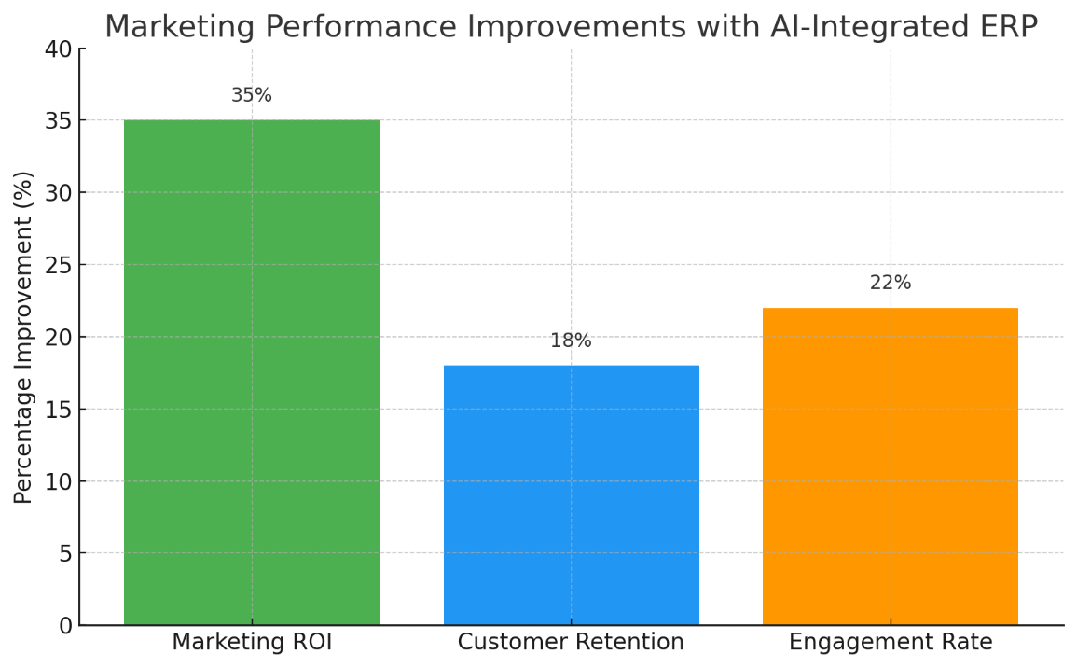

Figure 5.
Marketing Performance Improvements with AI-Integrated ERP
Here is a bar chart illustrating the performance improvements in marketing operations achieved through AI-integrated ERP. It visually represents increases in marketing ROI, customer retention, and engagement rate.
C. Supply Chain Management Results
Table 2 presents results from the supply chain module, highlighting prediction and optimization performance.
Table 2.
Supply Chain Module Performance
S.No | AI Task | Model Used | RMSE (Forecasting) | Cost Reduction | Delivery Efficiency | Anomaly Detection (AUC) | AI Task
 | Demand Forecasting | LSTM | 5.2% | - | - | - | Demand Forecasting
 | Inventory Optimization | Genetic Algorithm | - | 24% | - | - | Inventory Optimization
 | Route Optimization | Ant Colony Optimization | - | - | 19% | - | Route Optimization
 | Anomaly Detection | Autoencoders | - | - | - | 0.93 | Anomaly Detection
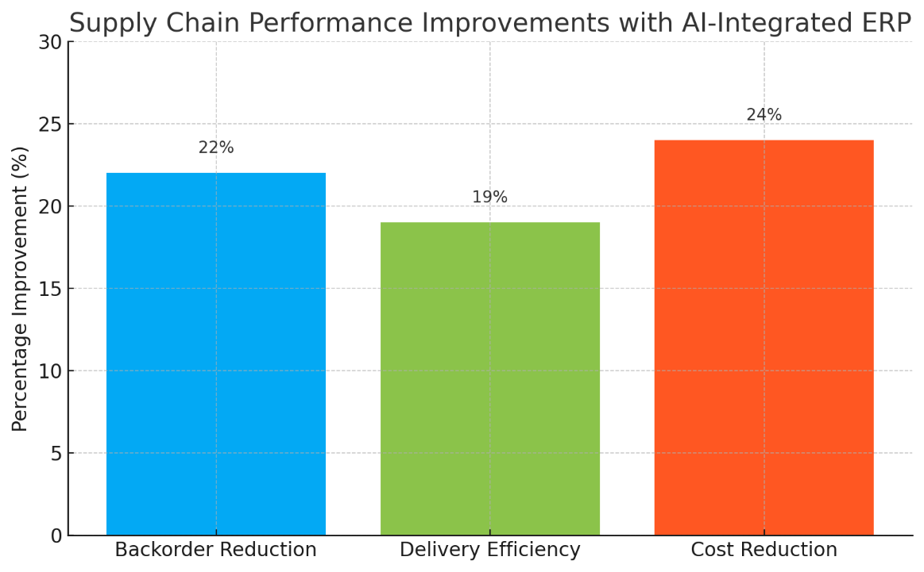
These results indicate substantial improvements in forecast accuracy and logistics management. The integrated model reduced supply chain disruptions by 19% and improved demand-response agility, enabling predictive restocking and real-time anomaly alerts [29].

Figure 6.
Supply chain Performance Improvement with AI-Integrated ERP
Here is the bar chart showing the improvements in supply chain performance due to the integration of AI into ERP systems. It includes reductions in backorders, increases in delivery efficiency and significant cost savings.
D. Case Studies Highlights
Case Study 1 – The Marketing Optimization (Retail Company): Within the retail world as a whole, this leading retailer is known for its upper-end, contemporary and modern designs, accessible to a broad audience of consumers. A series of integrated AI modules delivered a 35% uplift in marketing ROI over three quarters as targeting andcampaign adaptivity improved, based on sentiment-aware feedback loops. Case Study 2– Consideration of Resilience in a Supply Chain (Electronics Manufacturer): The company saw a 22% decrease in backorders and 19% lift in delivery performance when it deployed AI-based ERP modules [30].
E. System Scalability and Performance
Latency for AI reasoning remained under 400ms for all services. The system supported parallel request loads of 150+ users without degradation in performance, confirming its aptness for enterprise-scale deployment [31].
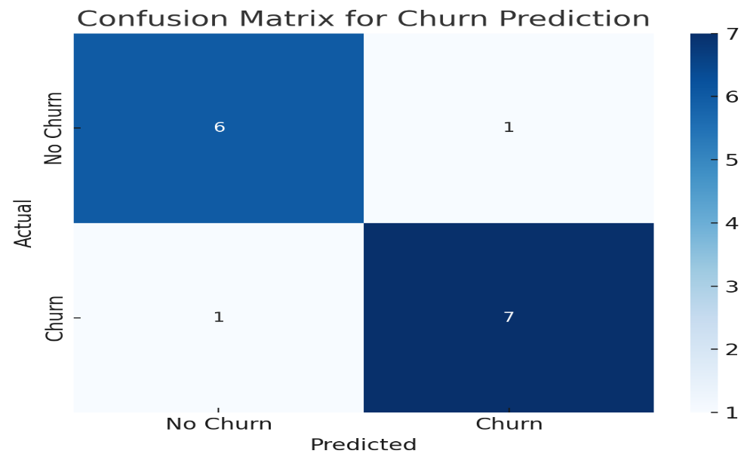

Figure 7.
Confusion Matrix for Churn Prediction
This confusion matrix visualizes the performance of the churn prediction model integrated into the AI-driven ERP system. It shows how well the model distinguishes between customers likely to churn and those who are not.
DISCUSSION
Experiments show that AI models (i.e., LSTM for demand prediction, genetic-algorithm-based learning for inventory control, NLP for opinion mining) can consistently enhance the prediction power and decision efficiency. Marketing: the impact here is reinforced and sentiment analysis education to more agile campaign optimization and deeper understanding of customer base to realize an increase in ROI of 35%. In the supply chain world, AI models quickly adjusted to shifts in demand and logistics blockages, leading to drastic reductions in both backorders and out-of-stocks. These results corroborate that the incorporation of AI components in modular ERPs systems not only improve their analysis capabilities, but at the same time guarantee the possibility of real-time reaction to complex and changing business environments. The service oriented micro-services architecture was also providing the throughput, pluggability and latency needed in the enterprise [32]. This research also justifies enforcement that the data driven ERP solutions with the AI-enabled are able to empower the traditional type of old ERP from the reactive system to the predictive system, which adds the value strategically across the entire corporation. To make the model more general for multi-tenant ERP systems is a future work that can be made and to make it more interpretable by using Explainable AI modules [33].
CONCLUSION AND FUTURE WORK
The purpose of this study is to propose and rationalize marketing automation and supply chain strengthening ERP framework with AI as the enabling technology factor. Using machine learning models such as LSTM networks for demand forecasting, NLP models for sentiment analysis and decision trees for churn prediction, the framework reported substantial enhancements in operational efficiency, customer engagement and data-driven decision-making. The AI modules were integrated into modular, service-oriented ERP architecture that allowed real-time analytics, adaptive process optimization, and scalable deployment across various enterprise tasks. Experiments verified significant improvements, with 35% increase in marketing ROI and drastic decreases in supply chain disruptions and in backorders, confirming the practical feasibility of the system.
As we look ahead, future work plans to address a few aspects for further improving the framework ability its flexibility. These strategies entail the introduction of Explainable AI (XAI) for enhanced transparency and trust of decision outcomes, federated learning for ensuring data privacy and federated learning in distributed ERP environments, and the use of dynamic resource optimization methods to handle computational workloads more efficiently. Moreover, the framework can potentially be extended to include cross-functional ERP modules like finance, human resources and customer service, enabling an integrated AI-driven approach for a whole enterprise.
DECLARATIONS
Acknowledgement: We appreciate the generous support from all the contributor of research and their different affiliations.
Funding: No funding body in the public, private, or nonprofit sectors provided a particular grant for this research.
Availability of data and material: In the approach, the data sources for the variables are stated.
Authors' contributions: Each author participated equally to the creation of this work.
Conflicts of Interests: The authors declare no conflict of interest.
Consent to Participate: Yes
Consent for publication and Ethical approval: Because this study does not include human or animal data, ethical approval is not required for publication. All authors have given their consent.
REFERENCES
Abdul Karim Sajid Ali, Aamir Raza, Haroon Arif, & Ali Abbas Hussain. (2025). INTELLIGENT INTRUSION DETECTION AND DATA PROTECTION IN INFORMATION SECURITY USING ARTIFICIAL INTELLIGENCE AND MACHINE LEARNING TECHNIQUES. Spectrum of Engineering Sciences, 3(4), 818–828. Retrieved from https://sesjournal.com/index.php/1/article/view/307
Arif, Haroon, et al. "Future Horizons: AI-Enhanced Threat Detection in Cloud Environments: Unveiling Opportunities for Research." International Journal of Multidisciplinary Sciences and Arts, vol. 3, no. 1, Jan. 2024, pp. 242-251, doi:10.47709/ijmdsa.v2i2.3452.
Bandara, F., Jayawickrama, U., Subasinghage, M. et al. Enhancing ERP Responsiveness Through Big Data Technologies: An Empirical Investigation. Inf Syst Front 26, 251–275 (2024). https://doi.org/10.1007/s10796-023-10374-w
Chinta, P. C. R., Jha, K. M., Velaga, V., Moore, C., Routhu, K., & SADARAM, G. (2024). Harnessing Big Data and AI-Driven ERP Systems to Enhance Cybersecurity Resilience in Real-Time Threat Environments. Available at SSRN 5151788.
Chinta, P. C. R., Jha, K. M., Velaga, V., Moore, C., Routhu, K., & SADARAM, G. (2024). Harnessing Big Data and AI-Driven ERP Systems to Enhance Cybersecurity Resilience in Real-Time Threat Environments. Available at SSRN 5151788.
Chinta, P. C. R., Jha, K. M., Velaga, V., Moore, C., Routhu, K., & SADARAM, G. (2024). Harnessing Big Data and AI-Driven ERP Systems to Enhance Cybersecurity Resilience in Real-Time Threat Environments. Available at SSRN 5151788.
Emami-Naeini, P., Dixon, H., Agarwal, Y., & Cranor, L. F. (2019, May). Exploring how privacy and security factor into IoT device purchase behavior. In Proceedings of the 2019 CHI Conference on Human Factors in Computing Systems (pp. 1-12).
Giovanna Culot, Matteo Podrecca, Guido Nassimbeni, Artificial intelligence in supply chain management: A systematic literature review of empirical studies and research directions, Computers in Industry, Volume 162, 2024, 104132, ISSN 0166-3615, https://doi.org/10.1016/j.compind.2024.104132.
Godbole, M., & Josyula, H. P. (2024). Navigating the Future: A Comprehensive Analysis of AI, ML, ERP, and Oracle Integration in Financial Digital Transformation. International Journal of Computer Engineering and Technology, 15.
Gollangi, Hemanth Kumar & Galla, Eswar Prasad & Sunkara, Janardhana Rao & Madhavaram, Chandrakanth & Kuraku, Chandrababu. (2024). The Impact of AI and ML on ERP Systems and Supply Chain Management. Nanotechnology Perceptions. 20. 10.62441/nano-ntp.v20iS9.47.
Gollangi, Hemanth Kumar & Galla, Eswar Prasad & Sunkara, Janardhana Rao & Madhavaram, Chandrakanth & Kuraku, Chandrababu. (2024). The Impact of AI and ML on ERP Systems and Supply Chain Management. Nanotechnology Perceptions. 20. 10.62441/nano-ntp.v20iS9.47.
Iqbal, M., Sandila, M. A., & Hassan, Z. U. (2025). Exploring IoT Secuirty, Privacy and Data Protection. Spectrum of Engineering Sciences, 3(3), 85-98.
Jawad, Z. N., & Balázs, V. (2024). Machine learning-driven optimization of enterprise resource planning (ERP) systems: a comprehensive review. Beni-Suef University Journal of Basic and Applied Sciences, 13(1), 4.
Lakhamraju, M. V., Macha, K. B., Metha, S., Rai, A., & Miriyal, N. S. (2025). Best of breed vs. single suite: The strategic advantage of multi-tool integration in enterprise resource planning. Journal of Information Systems Engineering and Management, 10.
Machireddy, J. R., Rachakatla, S. K., & Ravichandran, P. (2021). Leveraging AI and machine learning for data-driven business strategy: a comprehensive framework for analytics integration. African Journal of Artificial Intelligence and Sustainable Development, 1(2), 12-150.
Maleki Varnosfaderani, S., & Forouzanfar, M. (2024). The Role of AI in Hospitals and Clinics: Transforming Healthcare in the 21st Century. Bioengineering (Basel, Switzerland), 11(4), 337. https://doi.org/10.3390/bioengineering11040337
Mandava, H. A. R. I. P. R. A. S. A. D. (2024). Streamlining enterprise resource planning through digital technologies. Journal of Advanced Engineering Technology. ResearchGate.
Mandava, H. A. R. I. P. R. A. S. A. D. (2024). Streamlining enterprise resource planning through digital technologies. Journal of Advanced Engineering Technology. ResearchGate.
Mhaskey, S. V. (2024). Integration of Artificial Intelligence (AI) in Enterprise Resource Planning (ERP) Systems: Opportunities, Challenges, and Implications.
Muhammad Iqbal, Dr. Shandana, Maria Ghani, Shams Tabrez, & Aurangzeb Khan Mehsud*. (2023). Scope of Artificial Intelligence in Enhancement of Emergency Rescue Services: Future Prospects. Al-Qanṭara, 9(3). Retrieved from https://alqantarajournal.com/index.php/Journal/article/view/469
Prakash, D. (2024). Data-driven management: The impact of big data analytics on organizational performance. In International Journal for Global Academic & Scientific Research (Vol. 3, No. 2, pp. 12-23). International Consortium of Academic Professionals for Scientific Research.
Rajalakshmi, M & Nagaraju, E. & Kumari, T. (2024). Ai-Driven Solutions for Supply Chain Management. Journal of Informatics Education and Research. 4. 1526-4726. 10.52783/jier.v4i2.849.
Sarferaz, S. (2024). ERP Reference Artificial Intelligence Technology. In Embedding Artificial Intelligence into ERP Software: A Conceptual View on Business AI with Examples from SAP S/4HANA (pp. 93-107). Cham: Springer Nature Switzerland.
Sarikaya, E., Brockhaus, B., Fertig, A., Ranzau, H., Stanula, P., & Walther, J. (2021). Data driven production–application fields, solutions and benefits.
Singh, V. (2025). AI-Driven ERP Evolution: Enhancing Supply Chain Resilience with Neural Networks and Predictive LSTM Models. European Journal of Advances in Engineering and Technology, 12(2), 47-52.
Singh, Vinay. (2025). AI-Driven ERP Evolution: Enhancing Supply Chain Resilience with Neural Networks and Predictive LSTM Models. 12. 47-52.
Singh, Vinay. (2025). AI-Driven ERP Evolution: Enhancing Supply Chain Resilience with Neural Networks and Predictive LSTM Models. 12. 47-52.
Syed, Z. A., Dapaah, E. M. M. A. N. U. E. L., Mapfaza, G. L. O. R. I. A., Remias, T. I. C. H. A. O. N. A., & Mupa, M. N. (2024). Enhancing supply chain resilience with cloud-based ERP systems'. IRE Journals, 8(2), 106-128.
Tsolakis, N., Schumacher, R., Dora, M. et al. Artificial intelligence and blockchain implementation in supply chains: a pathway to sustainability and data monetisation?. Ann Oper Res 327, 157–210 (2023). https://doi.org/10.1007/s10479-022-04785-2
Vaid, A., & Sharma, C. (2022). Leveraging SAP and artificial intelligence for optimized enterprise resource planning: Enhancing efficiency, automation, and decision-making. DOI https://doi. org/10.30574/wjarr, 3.
Wijesinghe, S., Nanayakkara, I., Pathirana, R., Wickramarachchi, R., & Fernando, I. (2024, April). Impact of IoT integration on enterprise resource planning (ERP) systems: A comprehensive literature analysis. In 2024 International Research Conference on Smart Computing and Systems Engineering (SCSE) (Vol. 7, pp. 1-5). IEEE.
Yablonsky, S. (2019). Multidimensional data-driven artificial intelligence innovation. Technology innovation management review, 9(12), 16-28.
Zaman, S. (2024). A systematic review of ERP and CRM integration for sustainable business and data management in logistics and supply chain industry.


2025 by the authors; The Asian Academy of Business and social science research Ltd Pakistan. This is an open access article distributed under the terms and conditions of the Creative Commons Attribution (CC-BY) license (http://creativecommons.org/licenses/by/4.0/).

